Montana Event Services
UC Room 340
University of Montana
ucevents@mso.umt.eud
406-243-4119
Missoula, Montana

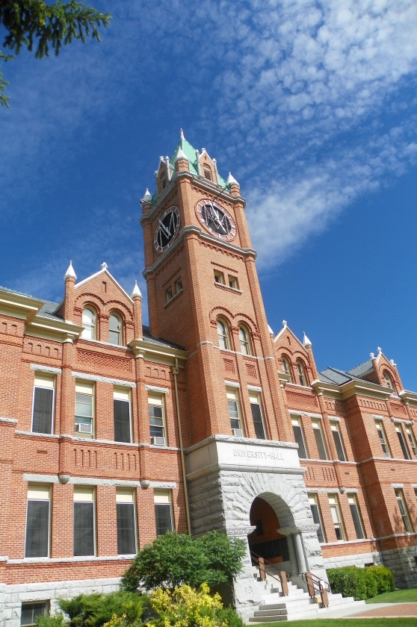
We welcome you to Missoula and UM.
Thank you for inquiring with the University of Montana housing and meal options for theInternational Choral Festival, 2016 groups. Choosing the University of Montana for your event offers your group the convenient and affordable services and venues. Nestled at the conversance of five valleys and three rivers in Western Montana, we invite you to explore what makes this place so special.

Content
We welcome you to Missoula and UM. 1
Over Night Sleeping Accommodations 2
Dining Opportunities 2
Recreation 4

Over Night Sleeping Accommodations
Campus Resident Halls have overnight sleeping rooms as a convenient and affordable option for your group. There are also several hotel options located within walking distance from campus.
Campus Accommodations
Available Dates:
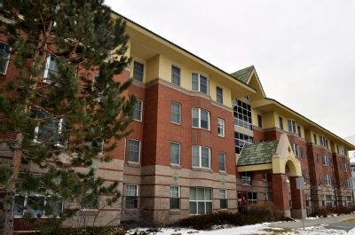
Housing for your group is available from 7/11/16 through 7/18/16. All rooms are furnished with two twin beds, closet, dresser, table, chair, bed linens and a towel.
Campus Housing Rates and Other Fees
Double Room Rate (roommates assigned for individuals) | $22.40* per person, per night
Single Room Rate (limited availability) | $30.24* per night
 | *Rates based on 2015 rates and include the 7% Bed Tax. Room rate and tax rate are subject to change.Change could go up 3-5% from 2015 rates.

Dining Opportunities
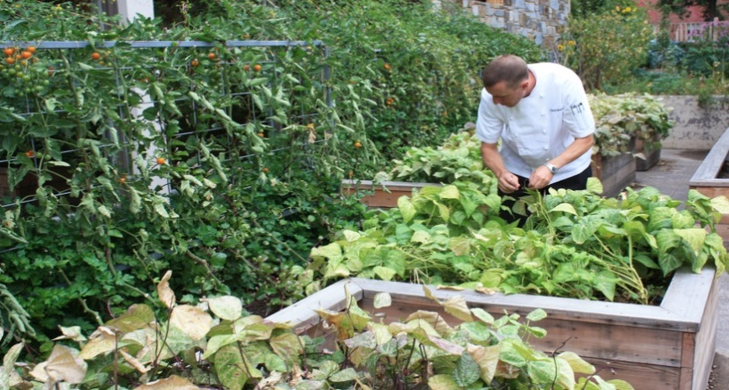
UM Dinning offers guests award winning dinning experiences to meet the unique needs of your group. Whenever possible, our ingredients are purchased, prepared and disposed of in the most local and sustainable way. Our campus gardens and local vendors ensure that your guests are enjoying the flavors of the freshest ingredients.

Food Zoo Summer Group Dining

2015 Pricing (2016 prices should be similar, but could have a 3-5% increase)
Contract Pricing  Breakfast $5.95  Lunch $7.95  Dinner $8.95 | Cash price for 13 and Older  Breakfast $9.25  Lunch $10.25  Dinner $11.25

Meals On-The-Go
Breakfast $6.00 | Lunch $8.00 | Dinner $9.00

Food Zoo Group Meal Dining Hours:
- Breakfast: 7:00am - 8:30am
- Lunch: 11:30am - 1:00pm
- Dinner: 5:00pm - 6:30pm
Menu selection and service will change to accommodate group size.
The guaranteed number of guests who will eat are due 7 business days in advance.
Your group will be charged for the actual number of guests served or the guarantee, number, whichever is greater. Group's will be billed at the cash price for individuals exceeding their guarantee by 10% or more for that meal.
Meals times for your group could possibly be altered to meet your groups schedule. This request will need to be arranged for and approved ahead of time.

Access Cards
Access to housing and meals are loaded onto the individuals access cards
There is a $1 per card charge for the meal/dorm cards.

Recreation
As a guest of campus, there are many recreation opportunities for your group. Please keep these in mind as you are planning your recreational activities.
Outdoor Recreation Program:
The Fitness and Recreation Center is the headquarters for Campus Recreation’s nationally recognized Outdoor Program, which offers:
Outdoor Equipment Rentals: A large inventory of outdoor gear is available to rent including rafts, kayaks, inner tubes, mountain bikes, camping gear, climbing equipment, cross-country skis, snowshoes, and more!

The Outdoor Program also manages an indoor climbing gym in the FRC. The climbing gym boasts 7,000 square feet of climbing surface area, 50 feet of vertical ascent and a bouldering cave.

